**TABLE OF SPECIFICATIONS FOR EXAM QUESTIONS**

**University of Liberal Arts Bangladesh**

**Department: Computer Science and Engineering (CSE)**

**Final Examination, Semester: Summer 2020**

**Program: B.Sc. in CSE**

**Course Code: CSE404 Course Title: Software Engineering Credit Hr: 3**

**Time: 2 Hours Total Marks: 25**

**Name & Designation of the Examiner: Satyaki Das, Lecturer**

**Learning Outcomes (LO):**

|  |
| --- |
| 1. **Describe** the objective of Software Engineering |
| 1. **Explain** terms related to important software engineering methods, process models, SRS, project management, testing. |
| 1. **Understand** a practical problem, **apply** software engineering principles and techniques to design a software to solve the problem. |
| 1. **Identify** product-related relevant information from Client’s input and **propose** solutions to solve the problems |
| 1. **Integrate** with a team and be willing to resolve conflicts. |
| 1. Learn to clearly communicate to **point out** ideas and concerns |

***Levels in Bloom’s Cognitive Domain:***

***C1: Remember C2: Understand C3: Apply C4: Analyze C5: Evaluate C6: Create***

|  |  |  |  |  |  |  |  |
| --- | --- | --- | --- | --- | --- | --- | --- |
| **Question No.** | **Learning Outcomes (CO)** | **Level in Bloom’s Cognitive Domain along with Allocation of Marks** | | | | | |
|  |  | **C1** | **C2** | **C3** | **C4** | **C5** | **C6** |
| 1 | 1 | 2 | 3 |  |  |  |  |
| 2 | 3 | 2 | 4 |  |  |  |  |
| 3 | 4 |  |  |  | 5 |  |  |
| 4 | 6 |  |  | 9 |  |  |  |
| **Total Allocation of Marks** | **25** | 4 | 7 | 9 | 5 |  |  |
|  |  |  |  |  |  |  |  |
| **Question No.** |  | **Learning Outcome** | | | | | |
|  |  | **CO1** | **CO2** | **CO3** | **CO4** | **CO5** | **CO6** |
| 1 |  | 5 |  |  |  |  |  |
| 2 |  |  |  | 6 |  |  |  |
| 3 |  |  |  |  | 5 |  |  |
| 4 |  |  |  |  |  |  | 9 |
| **Total Allocation of Marks** | **25** | 5 | 0 | 6 | 5 | 0 | 9 |



**Signature of the Examiner Date: 28.09.2020**

**Department of Computer Science and Engineering**

**University of Liberal Arts Bangladesh**

**Final Examination (Summer 2020)**

**Course: Software Engineering (CSE 404)**

**Section: 1 --- Duration: 2 Hours**

**______________________________________________________________________________________**

**PLEASE ANSWER ALL QUESTIONS. Total 25 Marks**

**QUESTION 1 (2+3=5 Marks)**

What are the differences between generic software products and customized products?

“Software costs more to maintain than to develop.” -Explain

**QUESTION 2 (2+2+2=6 Marks)**

What are some of the limitations of the Linear Sequential Model? How does the V-Model address those issues? What is the purpose of daily scrum events?

**QUESTION 3 (2+3=5 Marks)** Consider the following usage scenario for SafeHome:

*SafeHome is a microprocessor-based home security system that would protect against and/or recognize a variety of undesirable "situations" such as illegal entry, fire, flooding, and others. The system will consist of smoke detectors, window and door sensors, motion detectors, an alarm, an event (a sensor has been activated), a control panel, a display, telephone numbers, a telephone call, and so on. The list of services might include setting the alarm, monitoring the sensors, dialling the phone, programming the control panel, reading the display.*

Perform general classification and Object-Oriented Analysis to identify potential classes to develop the system.

**QUESTION 4 (1+1+2+2+1+2=9 Marks)**

A program reads an integer number within the range [1,100] and determines whether it is a prime number or not. Design test cases for this program using BVC, robust testing, and worst-case testing methods.

The code for the program is as below:

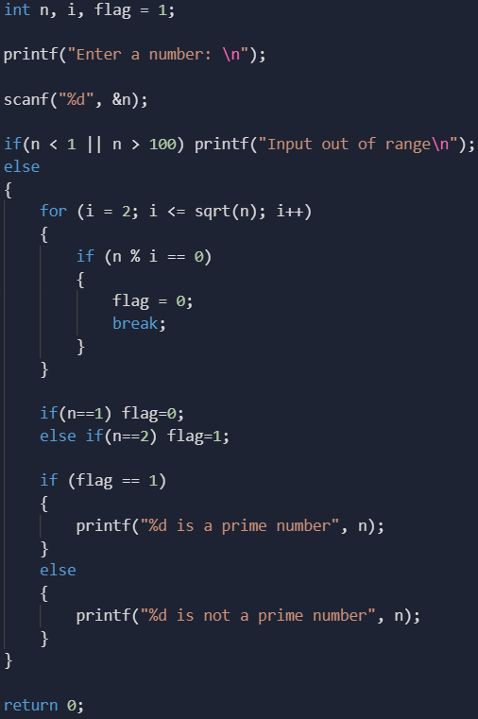

Draw the Control Flow Graph for the program, list all independent paths, calculate the cyclomatic complexity of the program using all three methods.

**\*\*END OF QUESTIONS\*\***